How to install Vivado in Linux

Created by: David Rubio G.
Blog: https://soceame.wordpress.com/
GitHub: https://github.com/DRubioG
Last modification date: 03/03/2025

After installing Vivado many times on Linux, I am here to give more details on how to install it on Linux and the packages that are required to install it.

Description
To start, the first thing you need to have in order to continue is the Vivado .bin installer.
Once you have it in your possession, we start by installing the Vivado dependencies, which are the following:
- libstdc++6:i386
- libgtk2.0-0:i386
- dpkg-dev:i386
- python3-pip
- libtinfo5
- libncurses5
All these dependency packages can be installed with the following command
sudo apt-get install libstdc++6:i386
sudo apt-get install libgtk2.0-0:i386
sudo apt-get install dpkg-dev:i386
sudo apt install python3-pip
sudo apt install libtinfo5 libncurses5
or its abbreviated version.
sudo apt-get install libstdc++6:i386 libgtk2.0-0:i386 dpkg-dev:i386 python3-pip libtinfo5 libncurses5
Once you have all the dependencies installed, we move on to installing Vivado.
To install Vivado, you must first run the command chmod +x <name> in order to install a .bin on Linux.
chmod +x ./<Vivado installer>.bin
Una vez lo hayas ejecutado tienes que lanzarlo. Para ello se hace con el './'
./<Vivado installer>.bin
**EXTREMELY IMPORTANT NOTE:
In order to appear in your Linux operating system's launcher the Vivado/Vitis/etc. logos, you do NOT have to run the installer in superuser mode (sudo). Otherwise, they will NOT appear in your operating system's launcher and you will have to launch Vivado from the terminal.
Once you launch it, the installation program screen will appear.
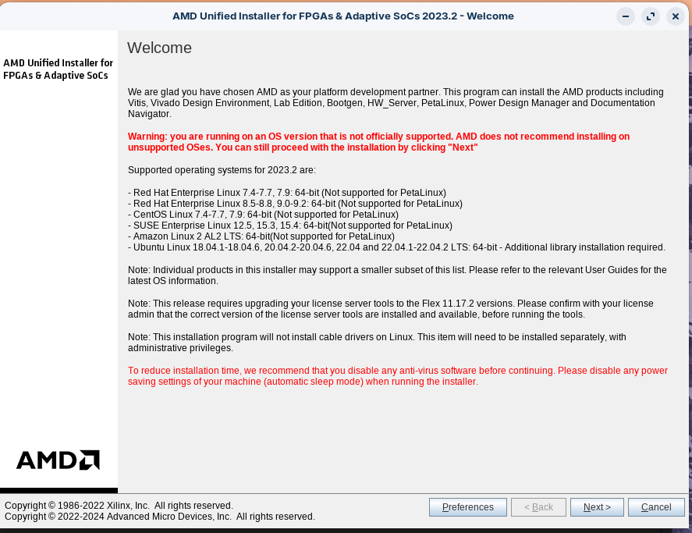
To install Vivado, Vitis and others, in the tab for choosing the program you want to install, you have to say that you want to install Vitis (the first option). To install all Xilinx tools, you need to have a minimum of 300Gb free space.
*NOTE: if you only want to install Vivado without any extra software, you have to select the Vivado option on this screen.

Finally, I'll leave you with a summary of the code you need to put into the terminal to install Vivado.
VIVADO=./<Vivado installer>.bin
sudo apt-get install libstdc++6:i386 libgtk2.0-0:i386 dpkg-dev:i386 python3-pip libtinfo5 libncurses5
chmod +x $VIVADO
$VIVADO

Installing the cable drivers
The last thing left to install is the drivers for the debug cables.
To do this you have to go to the folder where you have Vivado and follow this path:
/Vivado/<version>/data/xicom/cable_drivers/lin64/install_script/install_drivers/
In this folder there is an executable and a .sh.
For the installation you have to run the executable
./install_drivers
Once done the next time you connect a board, Vivado will detect it. (sometimes you need to wait a bit or restart your computer)

IMPORTANT NOTE
There are two options for installing Vivado:
- The normal installation of Vivado, in which you download the installer of about 200MB, and this installer opens the installation driver. This method on slow connections can make your installation take several hours to install.
- Download the self-installer, the self-installer is the option that Xilinx gives to be able to download Vivado without an internet connection. This option is highly recommended when you have very slow internet connections, because it downloads the Vivado installer faster than the normal installer.
NOTE: this installer can be downloaded from two different sites: the Vivado page (see image below) …
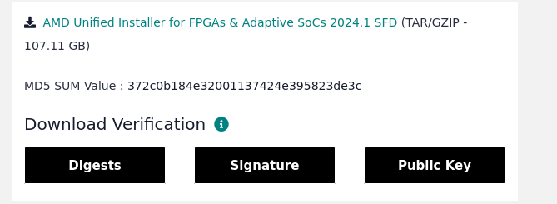
…or with the normal Vivado installer in the Download Image option, with this option you can choose where to install Vivado, the operating system on which you are going to install it, and if you want to choose the software you want to install (Selected Product Only) or download the installer that allows you to install all of them (Full Image). This installation option is slower than downloading the installer from the browser.
